Guide to Revise Firmware of VP-300

NOTICE

For FW3.02 and prior version, we strongly recommend users to use WCOMW as the only way to revise firmware, and after revision, remember to restore default factory settings.

Step-by-step instructions for revising firmware of VP-300

1. See Section 1 to use WCOMW connecting to VP-300
2. See Section 2 to check the version of loader and revise it if necessary.
3. See Section 3 to revise firmware

Section 1 To Use WCOMW

A. Use WCOMW connect to VP-300
- Connect COM2 port (or one empty serial port) of PC and COM1 port of VP-300 using an RS-232 cable (comes with VP-300).
- Insert the Setup Disk come with VP-300 into your floppy driver and copy all of those files to a directory of the PC and unzip the file: TeleWriter.zip.
- Launch WCOMW.EXE on PC (double click on the icon of that file while you are in Windows File Explorer)
- If you are using other COM port of your PC, please select it from File Menu.
- Power on VP-300.
- When you see "Starting Loader…” in WCOMW, press ESC key in 2 seconds and a loader information and menu will be displayed, and if you failed to press ESC key in 2 seconds, just restart VP-300 to do it again. If you don't see "Starting Loader..." in WCOMW and the menu is displayed directly, just go ahead.
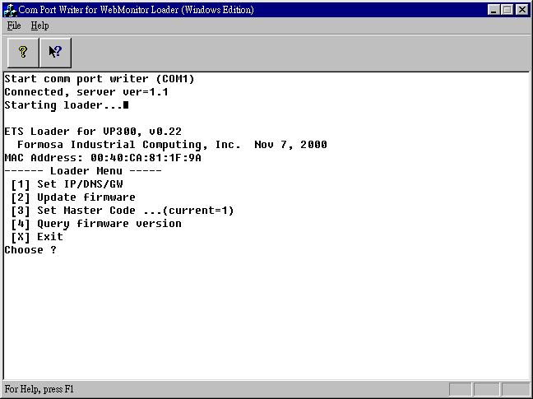
(WCOMW Menu Displayed)

ETS Loader for VP300, v0.22
←loader information
←loader menu
[1] Set IP/DMS/GW
[2] Update firmware
[3] Set Master Code ...
[4] Query firmware version
[X] Exit
Choose ?

Section 2 To Check the Version of Loader and Upgrade Loader

- The loader information would be displayed as following. You can also check the version of loader.
When you see “ETS Loader for VP-300, v0.22” in loader information, it means that the version of loader for VP-300 is v0.22. .

Loader versions and files for VP-300:
--------------------------------------------------------------------------------
loader version 0.22 file: ldr300.exe.022

Notice:
Before revising firmware, make sure the loader version of your VP-300 is v0.22 (or later).

- Press 'W', 'E', 'B', 'M', 'O', 'N' will pop up additional menu items as:

[5] Revise ETS LOADER
[6] Reboot
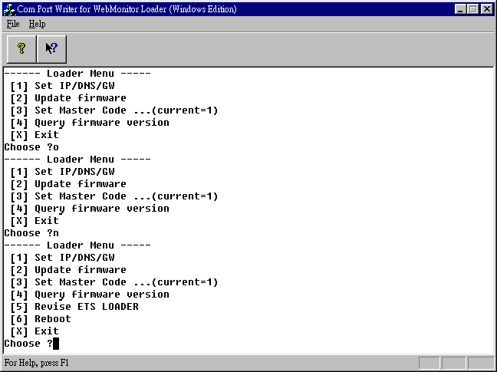
[X] Exit
(Additional Menu Popped up)

- Press 5 to revise loader, enter the full path and filename of the new loader.
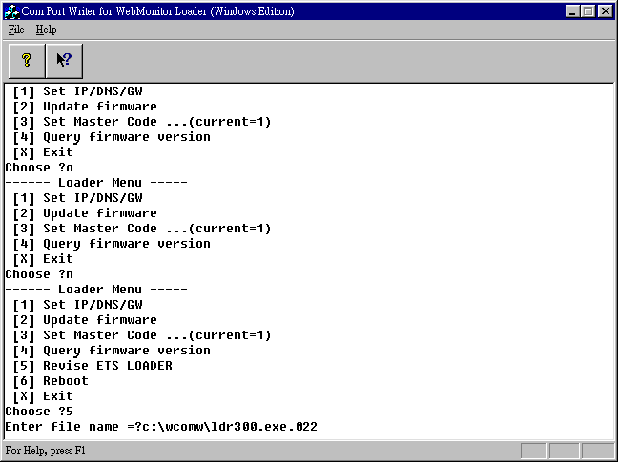
(Full Path and Filename of the New Version of Loader Entered)

- WCOMW is now uploading loader file to VP-300 for revision.
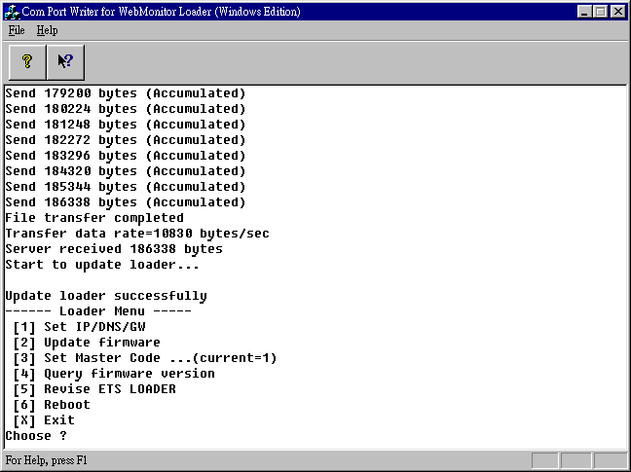
(ETS Loader Updated Successfully)

- After revision, you have to restart VP-300. Just switch the power of VP-300,

Section 3 To Revise firmware

- Press 2 to revise firmware.
- Enter the full path and filename of the new firmware.
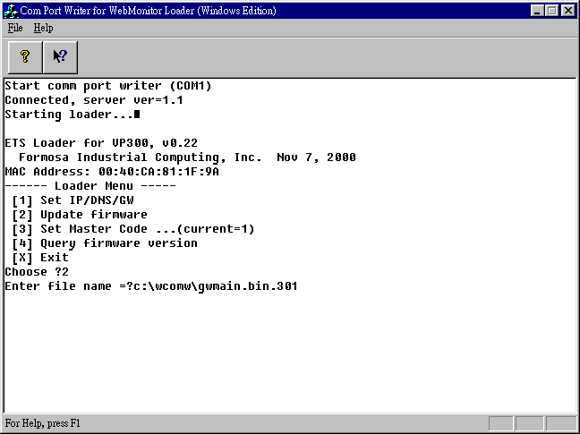
(Full Path and Filename of the New Version of Firmware Entered)

- WCOMW is now uploading firmware file to VP-300 for revision.
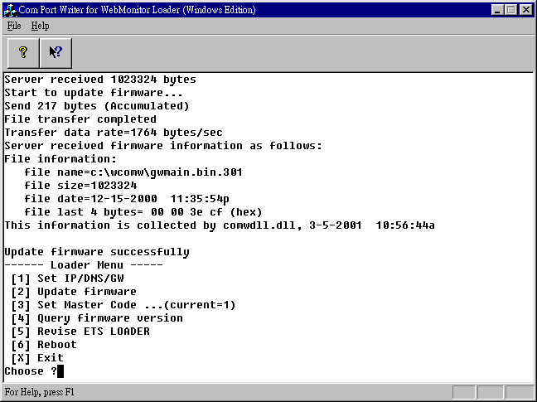
(Firmware Updated Successfully)

- After revision, press X to continue booting from the new firmware.
- After VP-300 is ready, push and hold default settings button until VP-300 stops beeping.
- VP-300 will restore default setting and reboot.
- You have completed updating firmware of VP-300, you can now continue to configure it and use the new firmware.

